Statistical Arbitrage Strategy

Introduction:
The goal of this project is to implement a robust Statistical Arbitrage (Stat-Arb) strategy to exploit temporary market deviations and mispricing’s across a universe of 40 crypto tokens. Stat-Arb strategies are fundamental to quantitative finance, seeking to profit when assets deviate from their statistically defined fair-value relationship. While often exemplified by pairs trading, where two historically correlated assets are traded based on the mean reversion of their price difference, this project employs the more generalized, multi-asset framework proposed by Avellaneda and Lee (2010). This strategy involves neutralizing common market risk by using Principal Component Analysis (PCA) to extract dominant risk factors, modeling the remaining idiosyncratic asset movements (residuals) as a mean-reverting process, and generating systematic buy/sell signals based on the resulting s-score. Ultimately, the project seeks to construct a systematic, market-neutral portfolio using unit-share transactions to evaluate the strategy's performance through key metrics like the Sharpe Ratio and Maximum Drawdown over the testing period.

Generating the Signals:
To generate the signals for the strategy, I created a StatArbModel class. This class allows me to cleany separate the steps in generating the strategy, as well as automating the workflow. It also gives me access to each individual steps for testing and debugging.
Step 1-Generating Factor Returns:
The first step in the project was to generate the returns for the two risk factors. This was implemented in the factor-generation function, which receives the cleaned return series produced by the return-generation step. The returns are first normalized, and a correlation matrix is constructed. PCA is then applied to this matrix to extract the first two eigenvectors, which are saved at each time step in the task1a_1 and task1a_2 CSV files. These eigenvectors are converted into the eigenportfolio weight vectors Q1 and Q2, and the corresponding factor returns at time t are computed by taking the weighted sum of token returns using these Q vectors. The resulting factor return series are then compared to the return behavior of Bitcoin (BTC) and Ethereum (ETH).

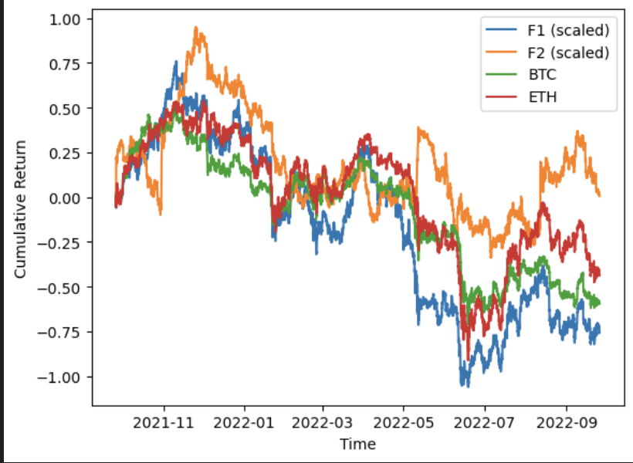
After generating the F1 and F2 factor return series from the eigen-portfolio construction, the raw outputs were large and unrealistic return values. This happened because the eigen-portfolio weights can become quite large due to the Q calculation procedure, and these portfolios are not meant to represent actual tradable strategies. Instead, the factors summarize the main sources of systematic risk driving the crypto market. To make the factors visually comparable to BTC and ETH, the F1 and F2 series were scaled down. This scaling does not change their meaning; it simply makes the plot readable. The important thing to focus on in the figure is the relative behavior of the factors, not their absolute magnitude. Once plotted, F1 closely follows BTC and ETH, indicating that it captures the dominant market movement and behaves like a broad market factor. F2, however, does not track BTC or ETH as closely. It shows some similarities at times, but overall moves differently, suggesting it represents a secondary source of variation in the market rather than the main trend.

Step 2 - Generating S-Scores
The S-scores were generated using the function generate_s_scores within the model class. This function takes the factor return series and, for each token, fits a linear regression model of that token’s returns on the two factors over the selected window. The purpose of this first regression is to isolate the residual component of each token’s return after accounting for the systematic movements captured by the factors. These residuals represent the idiosyncratic behavior of the token. Once the residual series is obtained, it is cumulatively summed to form the process X_l. The cumulative residual behaves like a mean-reverting signal if the token deviates from its long-run equilibrium. To quantify this behavior, a second regression is run where X_l+1 is regressed on X_l. This step produces the parameters a and b, which describe the mean-reversion dynamics. From the estimated values of a and b, we can compute the parameters k, m, sigma, and sigma_eq. These represent the speed of mean reversion, the long-run equilibrium level, the volatility of the residual process, and the equilibrium volatility, respectively. With these quantities, the S-score is calculated as a standardized measure of how far the current residual is from its equilibrium level. A high positive S-score suggests the token is unusually high relative to its mean and may be a sell signal, while a large negative S-score indicates the opposite. This score forms the basis for the trading rules used in the strategy.
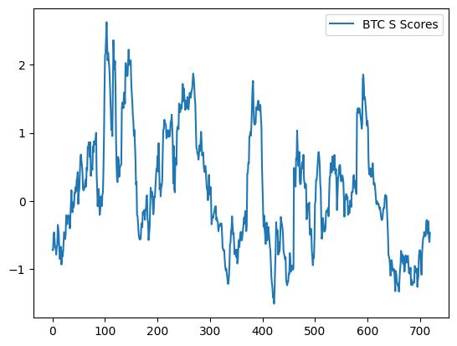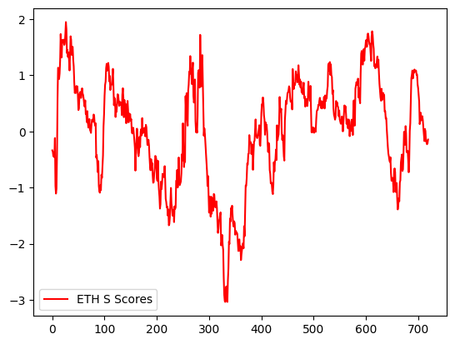
The S-scores for both BTC and ETH display this expected behavior. They frequently cross the zero line, oscillating between positive and negative values. This pattern indicates that their residual processes are continuously moving toward and away from their estimated equilibrium levels. In other words, the S-score dynamics show that BTC and ETH are regularly reverting toward their long-run mean, consistent with a mean-reversion process.

Step 3 – Generating Signals:
The last step to develop our trading strategy is done in the generate_signals function, which constructs a strategy based on the s-scores calculated earlier. The function begins with the previous signal, representing the current position, and checks whether the token is still part of our universe of 40 tokens. If it is not, any open position is closed. For tokens within the top 40, the strategy is applied as follows: a new short position is opened if the token's s-score is greater than S_so, and a long position is opened if the s-score is less than -S_bo. Open long positions are closed if the s-score rises above -S_sc, and open short positions are closed if the s-score falls below S_bc. The resulting signal vector for each token is returned, aggregated in the automate function, and prepared for testing.

Results:
To run the strategy, I created a class call Trading_strategy. This class has two functions, calculate mdd, and the simulation function. The simulation function is the core of our back testing and strategy, and It works by reading in the relevant signal and return datasets. To avoid lookahead bias, the signals are first shifted. Then, the indexes of the datasets are aligned to ensure that each signal corresponds to the correct token. The next step is weighting the positions, which is crucial for producing meaningful drawdown and return metrics. Without proper weighting, the portfolio could take on excessive leverage, causing the calculated returns to be artificially high or misleading. Weighting ensures that each position contributes appropriately relative to the portfolio size, keeping the performance measures realistic. After applying the weights, the strategy returns are calculated, followed by key performance metrics such as the Sharpe ratio and maximum drawdown.
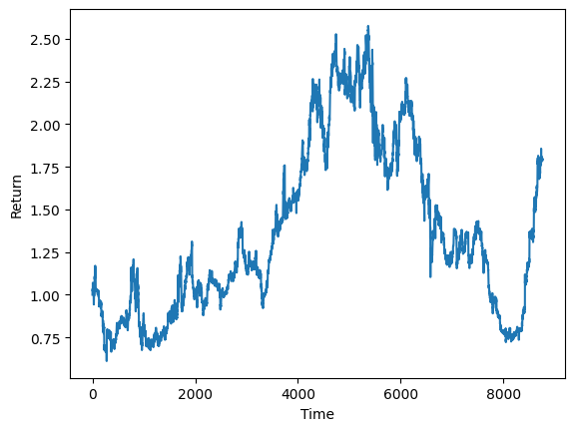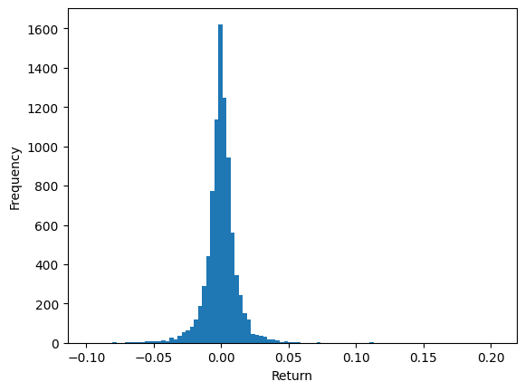
Based on testing, the optimal trading thresholds were S_bo = 1.9, S_so = 1.8, S_sc = 1.1, and S_bc = 1.2. Using these thresholds, the strategy produced a cumulative return of 0.79%, showing modest overall profitability. The Sharpe ratio of 1.08 indicates that the returns were achieved with relatively moderate risk relative to volatility. However, the maximum drawdown of -71% is extremely high, meaning the portfolio experienced a severe peak-to-trough loss during the testing period. This suggests that while the strategy can generate small gains, it carries significant downside risk and would be highly risky to implement in practice without adjustments to risk management or position sizing.

